**Comprehensive Guide to Removing Paint from Aluminum Soda Cans**

**Introduction**

Removing paint from aluminum soda cans is an important process for recycling and reusing aluminum in various applications. This document provides a structured overview of methods, including industrial processes, experimental techniques, and considerations for selecting the best approach.

**I. Industrial Methods for Large-Scale Paint Removal**

**1. Chemical Stripping in Controlled Environments**

* Large-scale use of industrial-grade chemical paint strippers. Effective but not environmentally friendly due to the use of industrial chemicals.
* Automated spraying or immersion systems.

**2. Pyrolysis (Thermal Paint Removal)**

* High-temperature ovens break down paint layers into ash. Efficient for large-scale operations but not eco-friendly due to high energy consumption.
* Residual ash is cleaned off with air or water.

**3. Abrasive Blasting**

* High-pressure media like glass beads or plastic pellets strip paint. Effective but the environmental impact depends on the recyclability of the media used.
* Enclosed systems recycle abrasive materials.

**4. Laser Ablation**

* High-energy lasers vaporize paint without damaging aluminum. Eco-friendly as it does not use chemicals and produces no waste.
* Ideal for precision applications.

**5. Electrochemical Cleaning**

* Paint is dissolved through electrolytic reactions in a controlled bath. Can be environmentally friendly if the electrolytes are non-toxic and properly managed.

**6. Hot Caustic Treatment**

* Submerging cans in hot sodium hydroxide baths. Effective but not eco-friendly due to the corrosive nature of sodium hydroxide.
* Paint dissolves through a caustic reaction.

**7. Mechanical Grinding or Polishing**

* Automated grinding or sanding systems remove paint layers. Not particularly eco-friendly due to potential particulate waste and energy use.

**8. Hydroblasting (High-Pressure Water Jetting)**

* High-pressure water jets strip paint efficiently. Environmentally friendly if wastewater is managed properly.

**II. Experimental and Innovative Methods**

**1. Bio-Based Paint Removal**

* Using enzymes or microbes to degrade paint naturally. Highly eco-friendly due to reliance on natural degradation processes.
* Environmentally friendly but slow.

**2. Supercritical Fluid Technology**

* Supercritical CO₂ dissolves paint without chemical residues. Eco-friendly as it uses recyclable CO₂ and avoids harmful chemicals.
* Requires high-pressure equipment.

**3. Plasma Treatment**

* Ionized gas ablates paint at the molecular level. Environmentally friendly as it is chemical-free and produces minimal waste.
* Chemical-free and precise.

**4. Ultrasonic Paint Removal**

* Ultrasonic vibrations in a liquid medium loosen paint particles. Eco-friendly as it avoids chemicals and minimizes environmental impact.

**5. Microwave-Assisted Paint Removal**

* Selectively heats paint layers for breakdown. Has the potential to be eco-friendly depending on energy sources.

**6. Advanced Laser Techniques**

* AI-guided lasers optimize precision and efficiency. Eco-friendly as it avoids chemicals and produces no waste.

**7. Electrolytic and Photocatalytic Systems**

* Combines electrochemical reactions with light catalysts to degrade paint. Environmentally friendly if non-toxic materials are used.

**.**

**8. Cryogenic Paint Removal**

* Liquid nitrogen or dry ice freezes and fractures the paint layer. Potentially eco-friendly but depends on the energy efficiency of the cooling systems.

**9. Magnetohydrodynamic (MHD) Methods**

* Magnetic and electric fields in a liquid medium agitate and strip paint layers. Experimental but has potential for eco-friendly applications.

**10. Green Solvent Development**

* Biodegradable or bio-based solvents dissolve paint effectively. Eco-friendly as they reduce reliance on toxic chemicals.

**III. Selection Criteria for Paint Removal Methods**

**1. Scale of Operation**

* Small-scale: Methods like sanding, boiling water, or acetone are suitable.
* Large-scale: Industrial techniques like pyrolysis, chemical stripping, or hydroblasting are preferred.

**2. Environmental Impact**

* Opt for methods with low chemical use, such as laser ablation or bio-based solutions, to meet sustainability goals.

**3. Cost Considerations**

* Chemical and caustic treatments are cost-effective.
* Laser and supercritical fluid methods involve higher upfront investment.

**4. Aluminum Quality Preservation**

* Techniques like hydroblasting, enzymatic methods, or ultrasonic removal are gentle on aluminum.

**5. Paint Type and Thickness**

* Stubborn or thick layers may require abrasive blasting or pyrolysis.
* Light layers can be removed using chemical or boiling water methods.

**IV. Companies in Thailand Specializing in Industrial Paint Removal**

**1.** [**Thai Beverage Can Ltd. (TBC)**](https://thaibeveragecan.com/)

* **Location:** Saraburi, Thailand
* **Description:** Leading aluminum can and end manufacturer engaged in closed-loop recycling of aluminum cans.

**2.** [**AL Solution Co., Ltd.**](https://www.alsolution.co.th/index-en.html)

* **Location:** Samut Sakhon, Thailand
* **Description:** Specializes in aluminum alloy production from recycled materials, including soda cans.

**3.** [**Metalcom Ltd.**](http://www.metalcom.co.th/)

* **Location:** Phanat Nikhom, Thailand
* **Description:** Operates a secondary aluminum alloy production facility focused on recycling aluminum products.

**4.** [**Swan Industries (Thailand) Limited**](https://swan.co.th/)

* **Location:** Bangkok, Thailand
* **Description:** One of the largest and most reliable can manufacturers in Thailand, producing a wide range of metal cans, including those for beverages and general use.

**5.** [**Alva Aluminium Ltd.**](https://alvathai.com/)

* **Location:** Rayong, Thailand
* **Description:** A Greenfield aluminum alloy manufacturing plant serving the automobile and auto die-casting industry in Thailand and Asia.

**6.** [**United Aluminium Industry Co., Ltd. (UAI)**](https://www.uai.co.th/en/)

* **Location:** Bangkok, Thailand
* **Description:** A leading manufacturer of extruded aluminum in Thailand and Southeast Asia, distributing products globally.

**7.** [**Tincan Industry Co., Ltd.**](http://www.tincan.co.th/)

* **Location:** Samut Prakan, Thailand
* **Description:** One of the oldest general can manufacturers in Thailand, producing various metal cans for over 40 years.

**8.** [**UACJ (Thailand) Co., Ltd.**](https://uath.uacj-group.com/)

* **Location:** Rayong, Thailand
* **Description:** A leading aluminum sheet manufacturer involved in the closed-loop recycling of aluminum cans.

**9.** [**Anglo Asia Group (Thailand) Co., Ltd.**](https://www.angloasiagroup.com/en/)

* **Location:** Bangkok, Thailand
* **Description:** Engages in recycling aluminum can scraps and processing them into high-purity recycled materials.

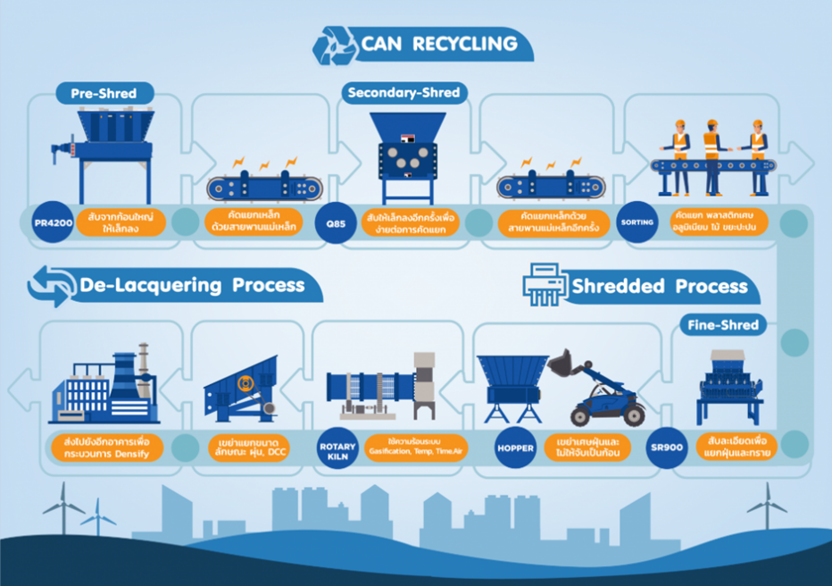

**V. Equipment for Industrial Paint Removal**

**Suny Group - Carbonization Furnaces**

* **Link:** [Suny Group - Key Equipment Removing Paint From Aluminum Cans](https://www.sunygroup.cn/news/Key-Equipment-Removing-Paint-From-Aluminum-Cans.html#:~:text=Carbonization%20furnaces%20are%20cutting%20edge,and%20paint%2Dfree%20aluminum%20surface.)
* **Description:** Carbonization furnaces utilize cutting-edge technology to thermally remove paint from aluminum cans, leaving a clean and paint-free aluminum surface. This equipment is highly efficient and widely used in industrial applications.

**Video - Industrial Paint Removal Process 1**

* **Link:** [YouTube Video - Industrial Paint Removal](https://www.youtube.com/watch?v=67pj5rFGRw8)
* **Description:** This video demonstrates an advanced industrial process for removing paint from aluminum soda cans, showcasing the equipment and techniques involved in large-scale operations.

**Video - Industrial Paint Removal Process 2**

* **Link:** [YouTube Video - Automated Paint Removal Process](https://www.youtube.com/watch?v=-xUJIpQOyMg)
* **Description:** This video highlights an automated system for paint removal, emphasizing efficiency and effectiveness in preparing aluminum cans for recycling or reuse.

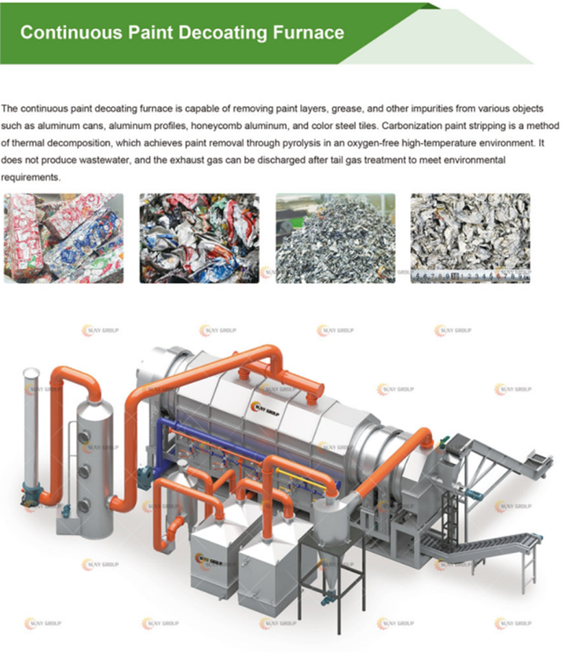

**VI. Conclusion**

The choice of paint removal method for aluminum soda cans depends on factors such as scale, environmental impact, and desired outcomes. Traditional methods are suitable for smaller operations, while industrial and experimental techniques provide scalable, sustainable options for larger or specialized needs. Continued innovation in experimental methods promises to make paint removal even more efficient and eco-friendly in the future.